**PanFab Commercial PAPR Blower Unit Assembly Instructions**

Akshay Kothakonda1 ,2, *, Lyla Atta1,3, *, Deborah Plana1 ,4,5, *, Ferrous Ward1 ,2, *, Chris Davis1,6, Avilash Cramer1 ,5, Robert Moran1 ,7, Jacob Freake1,8, Enze Tian1,9, Ofer Mazor1,10, Pavel Gorelik1,10, Christopher Van1,11, Christopher Hansen1,12, Helen Yang1,13, Michael S. Sinha1,13, Ju Li1,14, Sherry H. Yu1,15, Nicole R. LeBoeuf1,16, †,Peter K. Sorger1,4, †

1 Greater Boston Pandemic Fabrication Team (PanFab) c/o Harvard-MIT Center for Regulatory Science, Harvard Medical School, Boston, MA, USA

2Department of Aeronautics and Astronautics, MIT, Cambridge, MA, USA

3Johns Hopkins University School of Medicine, Baltimore, MD, USA

4Harvard Ludwig Cancer Research Center and Department of Systems Biology, Harvard Medical School, Boston, MA, USA

5 Harvard-MIT Division of Health Sciences & Technology, Cambridge, MA, USA

6GenOne Technologies, Cambridge, MA, USA

7Mine Survival, Panama City Beach, FL, USA

8Fikst Product Development, Woburn, MA, USA

9Beijing Key Laboratory of Indoor Air Quality Evaluation and Control, Department of Building Science, Tsinghua University, Beijing, China

10Research Instrumentation Core Facility, Harvard Medical School, Boston, MA, USA

11Borobot, Middleborough, MA, USA

12Harvard Graduate School of Design, Cambridge, MA, USA

13Harvard-MIT Center for Regulatory Science, Harvard Medical School, Boston MA, USA

14Department of Nuclear Science and Engineering and Department of Materials Science and Engineering, MIT, Cambridge, MA, USA

15Department of Dermatology, Yale School of Medicine, New Haven, CT USA

16 Department of Dermatology, Center for Cutaneous Oncology, Brigham and Women’s Hospital and Dana-Farber Cancer Institute, Boston, MA, USA

*These authors contributed equally to this work

†Co-corresponding authors. E-mails: nleboeuf@bwh.harvard.edu; peter_sorger@hms.harvard.edu cc: Maureen_Bergeron@hms.harvard.edu;

ORCID IDs:

Akshay Kothakonda, 0000-0001-5424-4228

Lyla Atta, 0000-0002-6113-0082

Deborah Plana, 0000-0002-4218-1693

Avilash Cramer, 0000-0003-0014-8921

Jacob Freake, 0000-0002-5198-835X

Enze Tian, 0000-0001-6410-5360

Christopher Van, 0000-0003-3262-964X

Christopher Hansen, 0000-0002-6640-2745

Ju Li, PhD, 0000-0002-7841-8058

Helen Yang, 0000-0002-9455-5300

Michael S. Sinha 0000-0002-9165-8611

Sherry H. Yu: 0000-0002-1432-9128

Nicole R. LeBoeuf, MD, MPH, 0000-0002-8264-834X

Peter Sorger, PhD, 0000-0002-3364-1838

**INTRODUCTION**

In assembling the prototype - two primary components had to come together in order to make the functional product. They can be categorized as 1) The mechanical housing that holds the electronics and 2) The electrical components which had to be soldered together and programmed to ultimately enable the prototype to function.

**MECHANICAL SETUP**

For the Pelican case, holes were first drilled in order to allow the filter cartridge, hose, and moisture-resistant switch to be installed. The drilling scheme of the case can be shown in **Figure 1.** On one of the larger flat faces, a 2.25-inch diameter hole saw was used to drill out the holes for the threaded filter housings. These holes were measured to be roughly six-inches apart center-to-center. On an adjacent, flat face, the same 2.25-in hole saw was used to drill out a hole for the outlet port. Additionally, a 0.5-inch hole was drilled out on the outlet port face with a standard HSS drill bit. Deburring tool was used to deburr this hole to assure tight sealing.

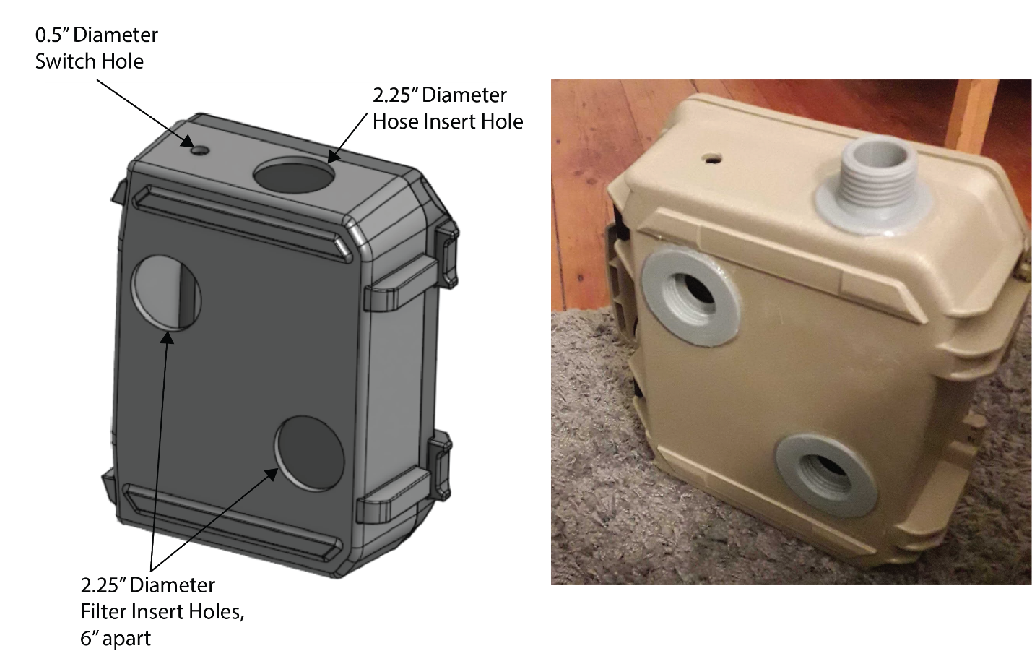

**Figure 1:** Rendering displaying the hole locations in the case, along with a photo of the assembled product.

Before the electronics were assembled, the two 3D-printed, filter inserts and one hose insert were glued to the case. To do this, the flanges of each insert was first fixed to the area surrounding the drilled holes with a cyanoacrylate glue - Loctite 420 (Loctite, Hartford, CT) in this case. This adhesive had a low viscosity (3 cP) and wicking characteristics that enable it to perform well in a sealing capacity. Mild pressure was placed on the parts while the glue cured - roughly 10 minutes. Afterwards, the three inserts were further fixed to the case with hot-melt adhesive. This was applied particularly to the interface between the edge of the 3D-printed flange and the Pelican case.

Then, the 3D-printed belt loops are glued using a suitable epoxy adhesive. This part may also be fixed using plastic welding. Prior to gluing the loops, it is advisable to position the waist belt in the appropriate position, and then glue the loops over it. **Figure 2** shows this step.

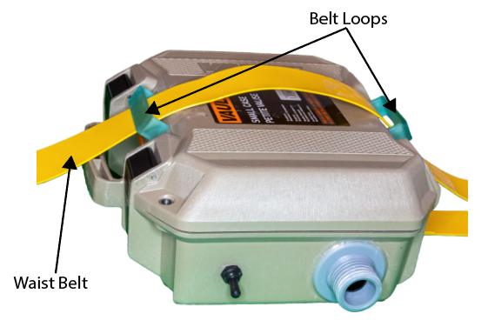

**Figure 2:** Assembly of belt loops and waist belt to the Pelican housing

From there, the electrical components were soldered and assembled.

**ELECTRICAL SETUP**

Electrical Assembly

To electrically assemble the components, the diagram described by **Figure 3** was ultimately followed**.** A custom printed circuit board (PCB) was developed for ease of assembly, as shown in **Figure 4**. The board will ultimately slot into the top of a standard Arduino Uno R3 (Arduino LLC, Boston, MA) to provide the power and data connections to various peripherals.

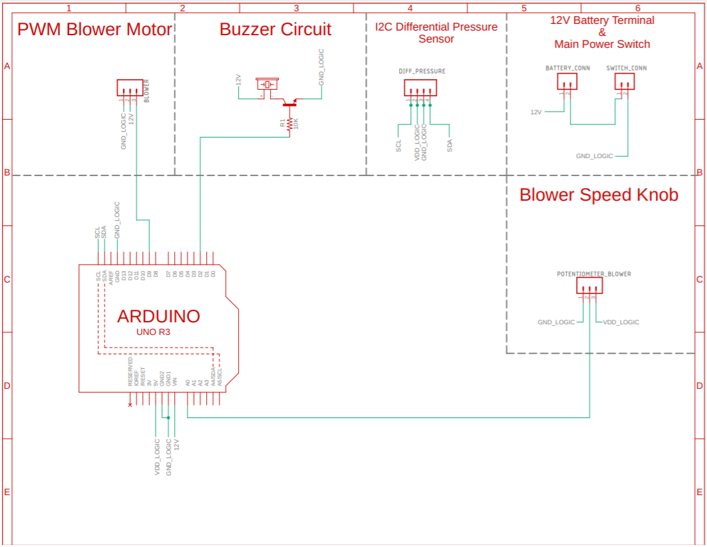

**Figure 3:** An electrical schematic describing the connections in the prototype.

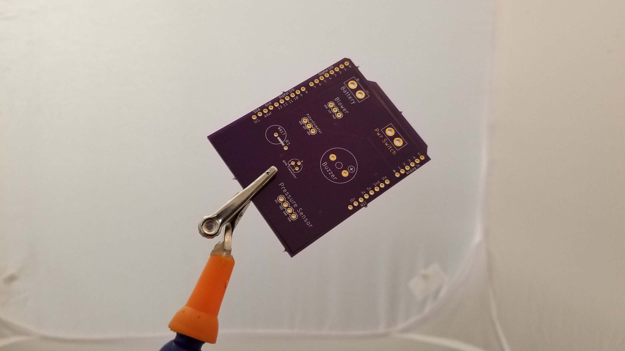**Figure 4:** A photo of the custom PCB used to connect various electrical components in the prototype.

Male header pins are first inserted into the female headers of the Arduino Uno, as shown in **Figure 5.** From there, the custom PCB is inserted on top of the Arduino Uno to align the male header pins then soldered **(Figure 6).**  The white superficial text (to help with component placement) should be facing up.The resulting PCB can then be separated from the Arduino Uno with the male header pins soldered on **(Figure 7)**. A 220-ohm through-hole resistor and a TO-92-3 2N3904BU BJT transistor are then soldered directly to the top of the PCB, as shown in **Figure 8.** The base, collector, and emitter of the transistor match up with the markings on the PCB.

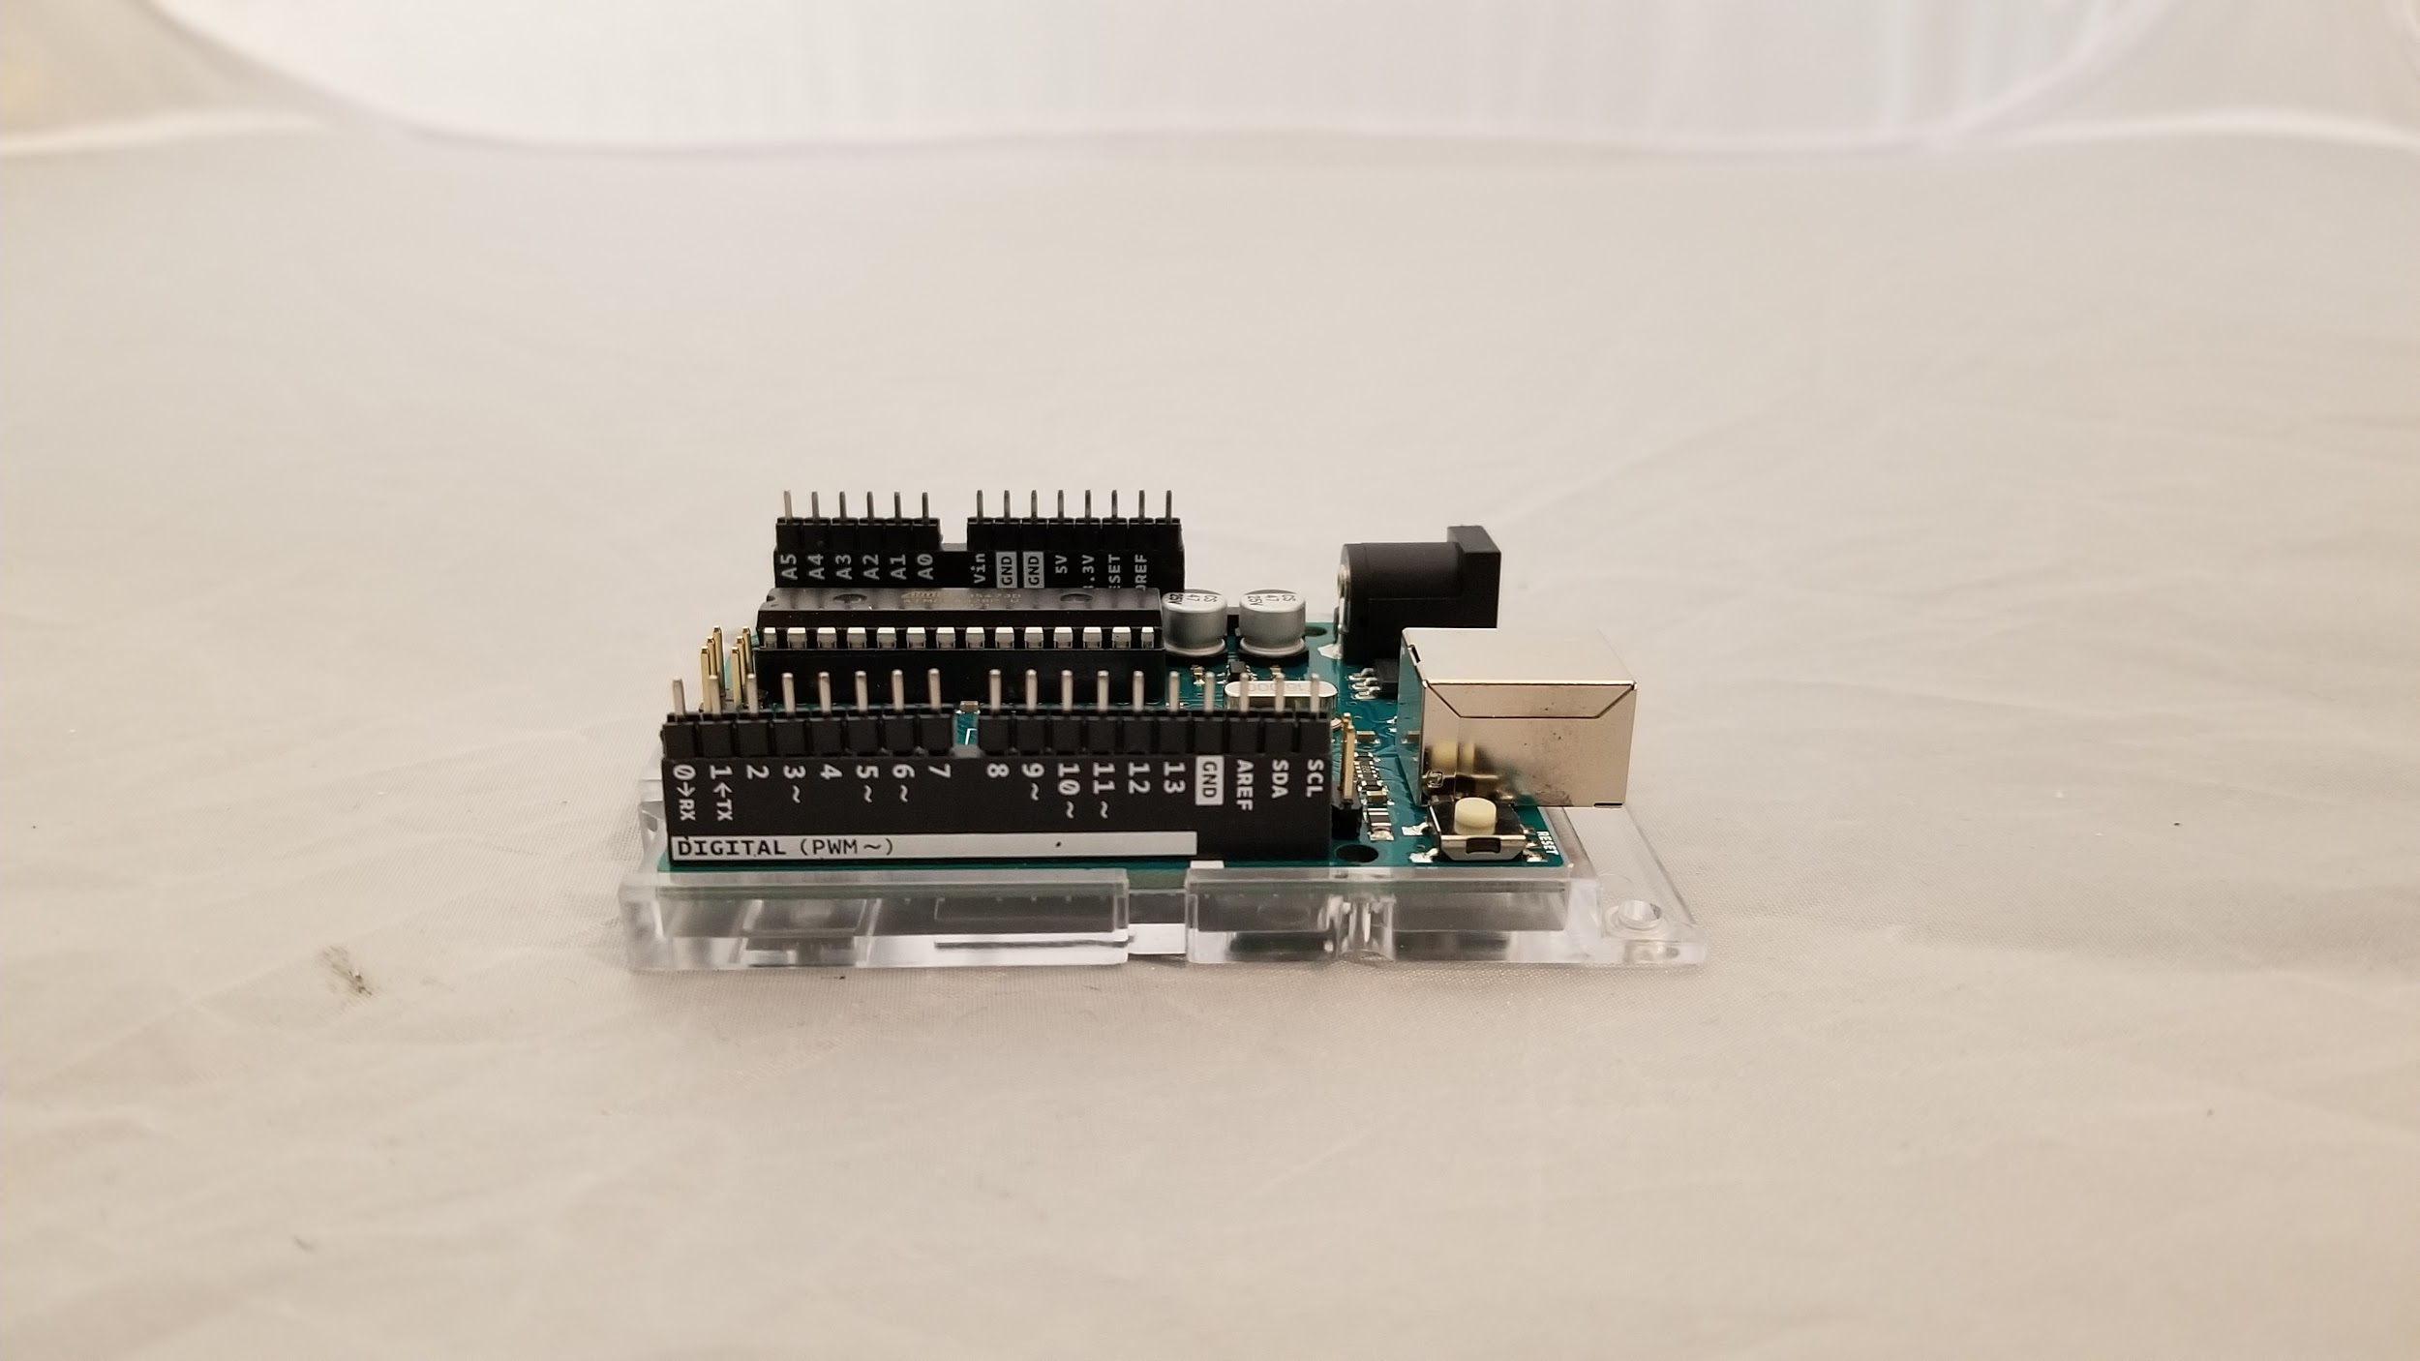

**Figure 5:** Male header pins are inserted into the IO ports of the Arduino Uno.

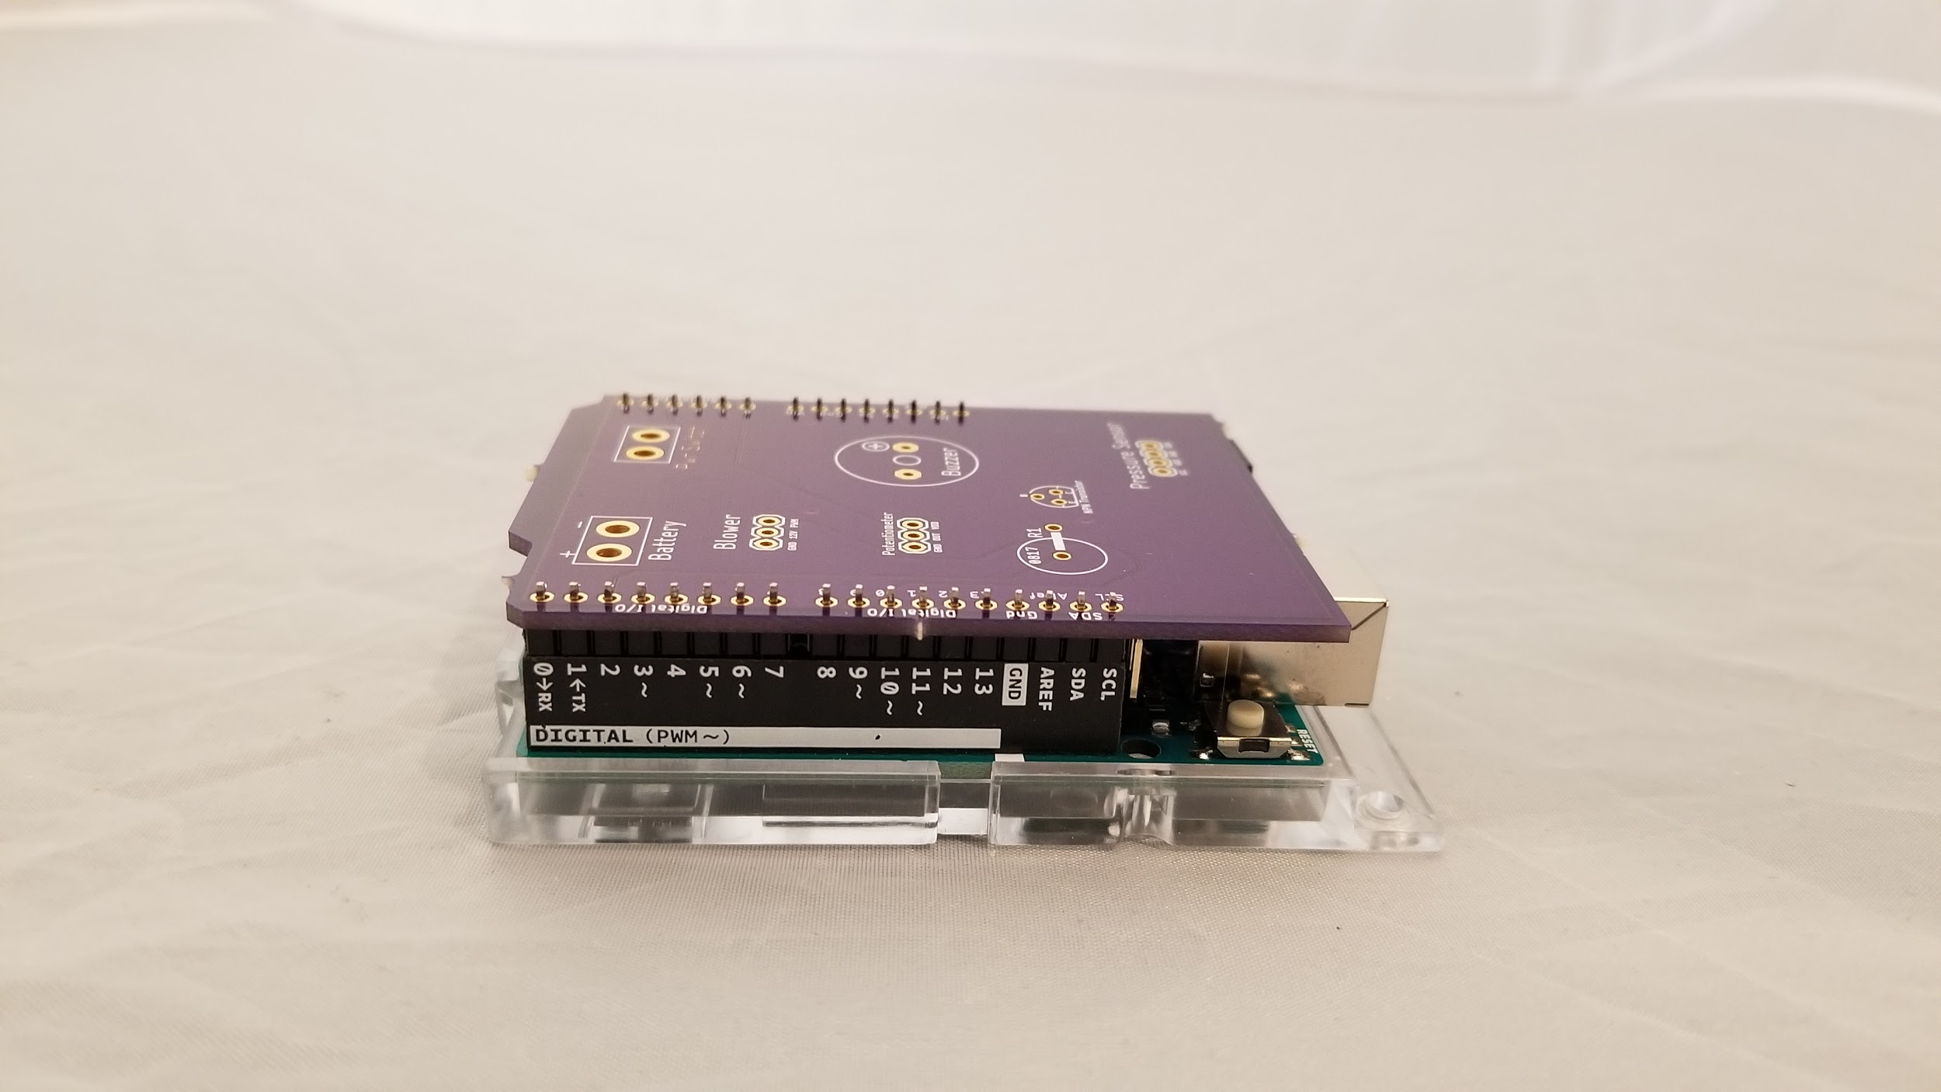

**Figure 6:** The custom PCB is placed on top of the male header pins and the Arduino Uno.

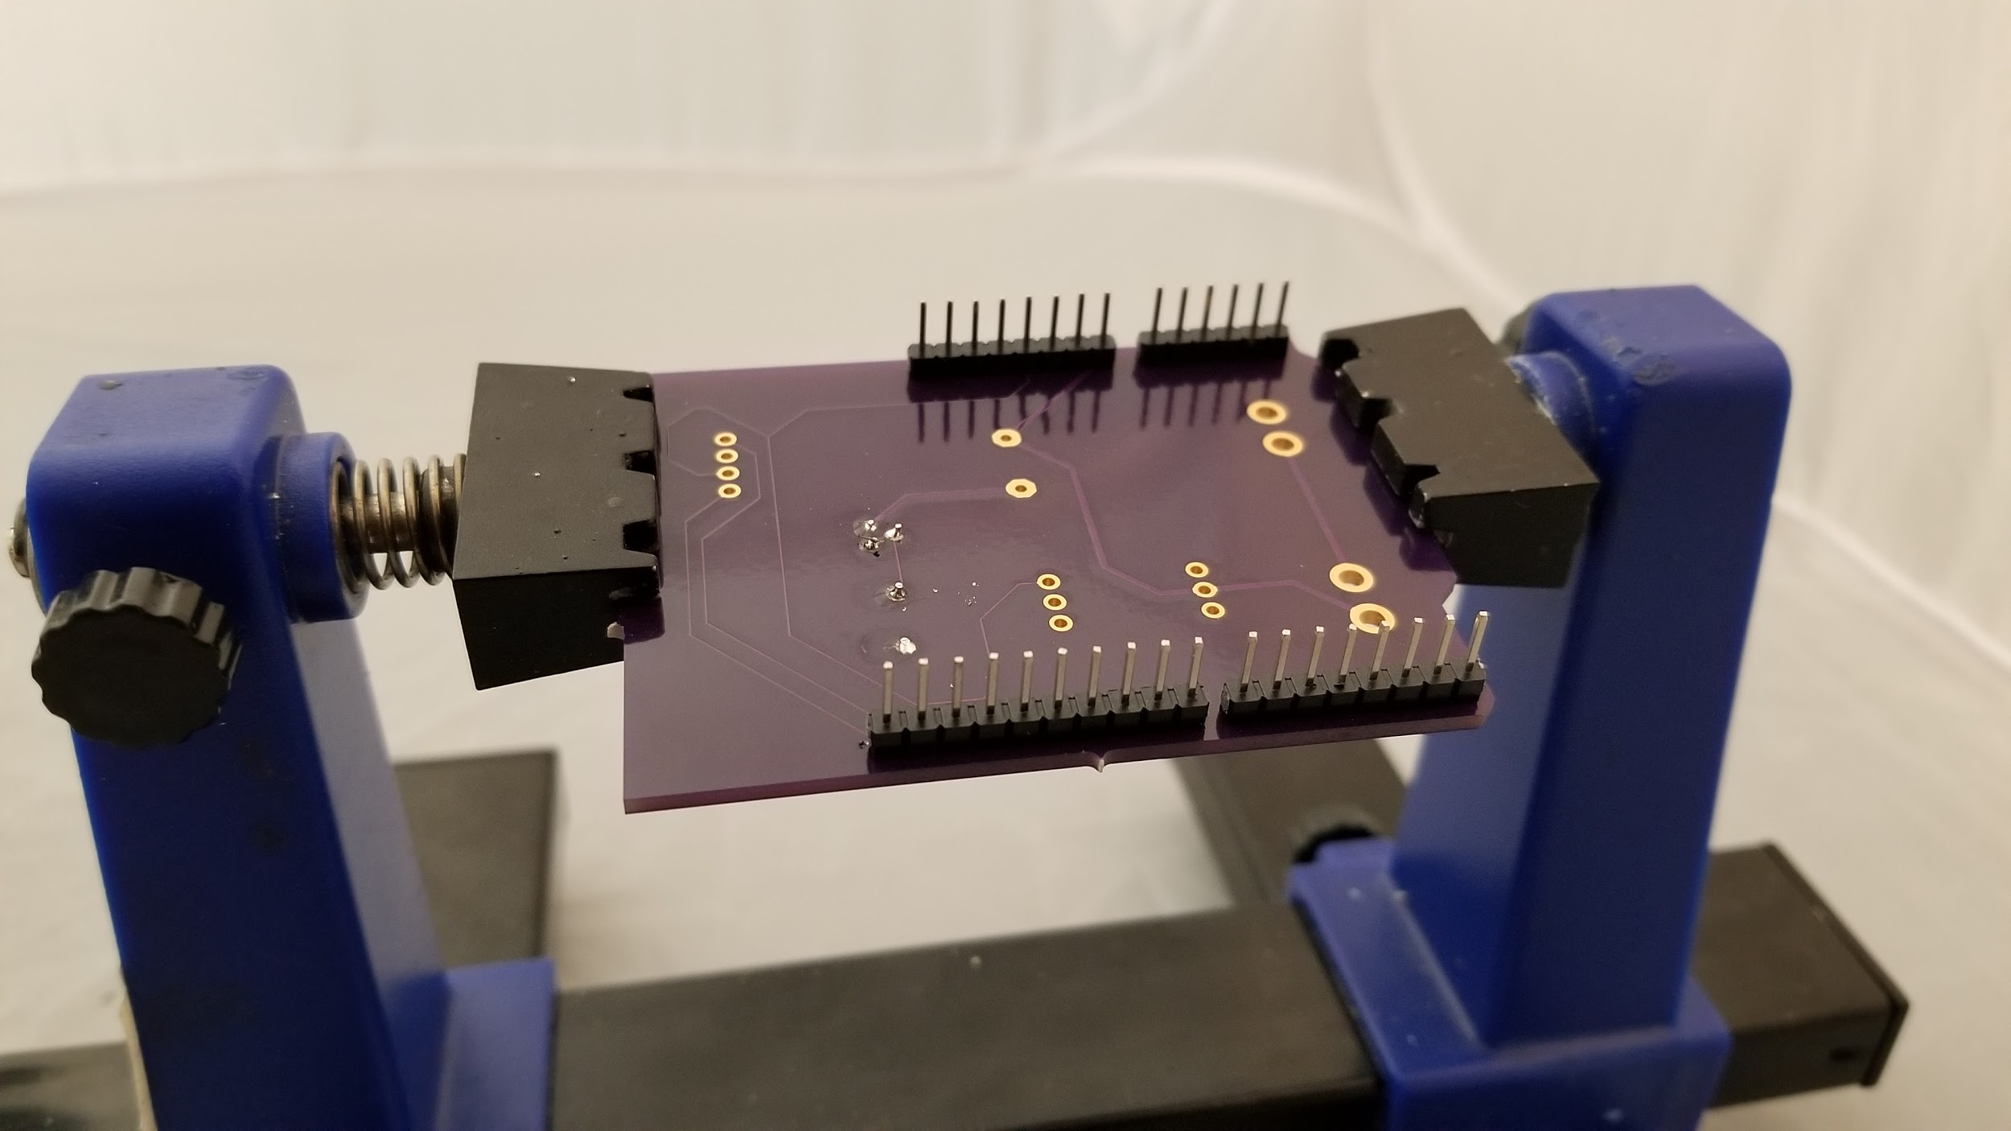

**Figure 7:** The male header pins successfully soldered to the custom PCB.

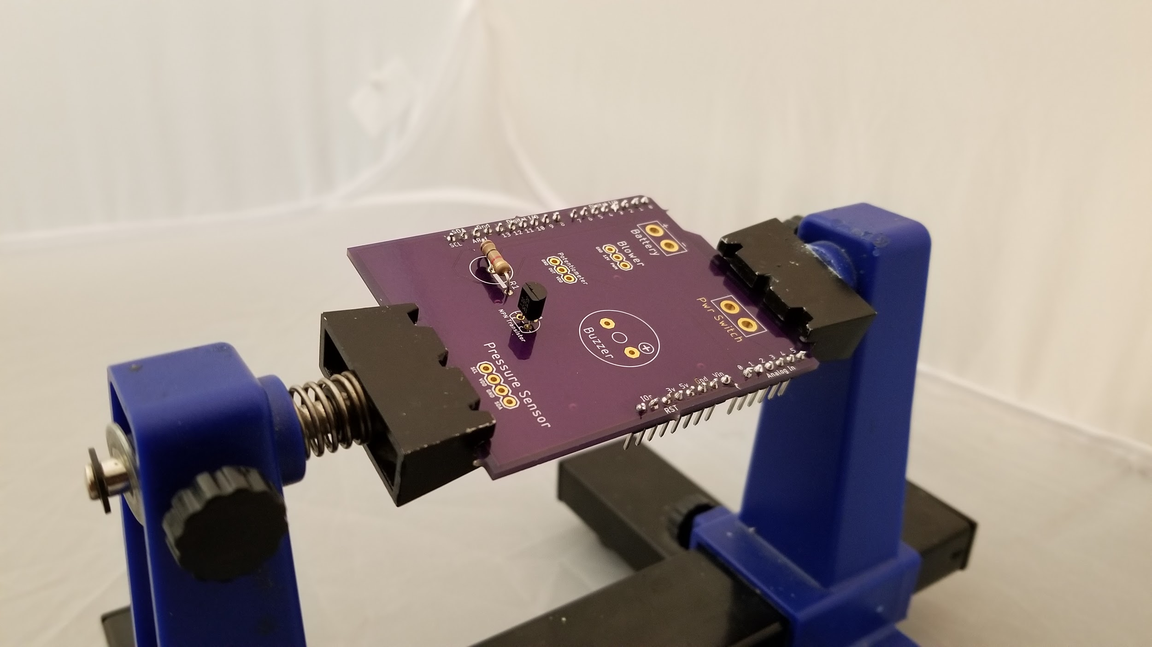

**Figure 8:** The resistor and BJT successfully soldered to the custom PCB.

Next, the male battery terminal connector with the visible metal pins was obtained and ultimately soldered to the portion of the PCB labelled *Battery*. Care was taken to make sure that the red wire is soldered to the terminal closer to the “+” marking, and the black wire is soldered to the terminal closest to the “-” marking **(Figure 9)**. The accompanying female battery terminal was then soldered to the terminals of the NiMH battery and secured with heat-shrink tubing **(Figure 10).** Additionally, two 12-gauge wires are soldered to the terminals labelled *Pwr Switch***.** To improve wire management, the wires were twisted in a standard power drill to create a twisted pair **(Figure 11)**.

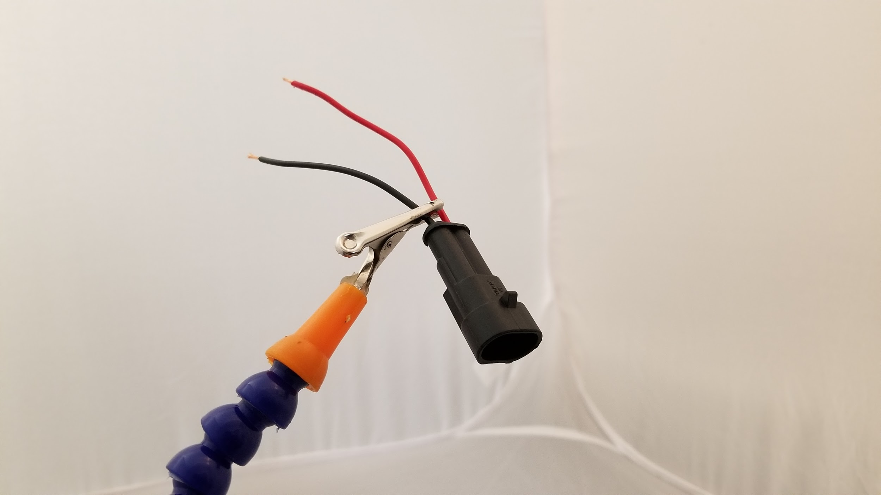 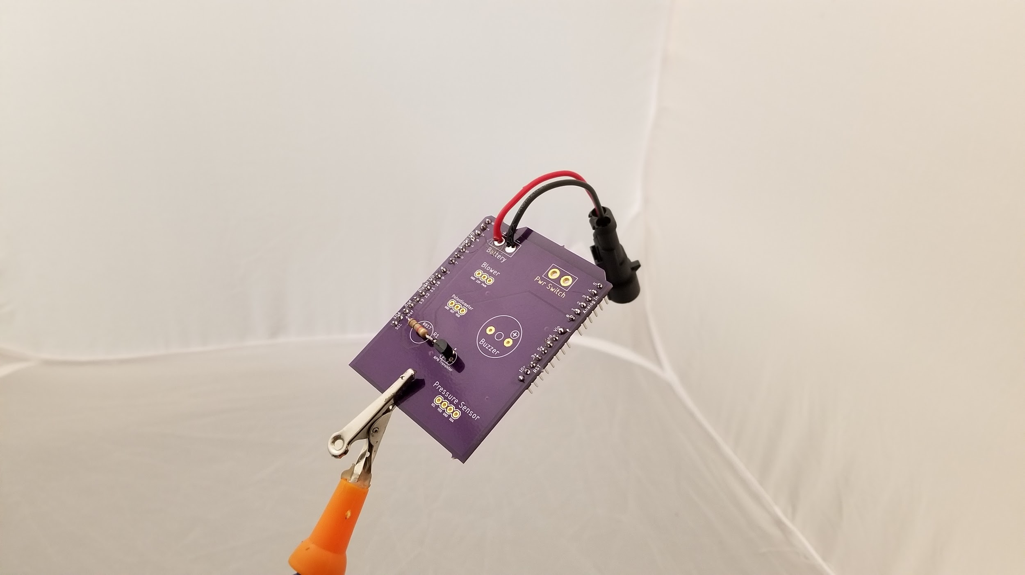

**Figure 9:** The male battery connector before and after being soldered to the PCB.

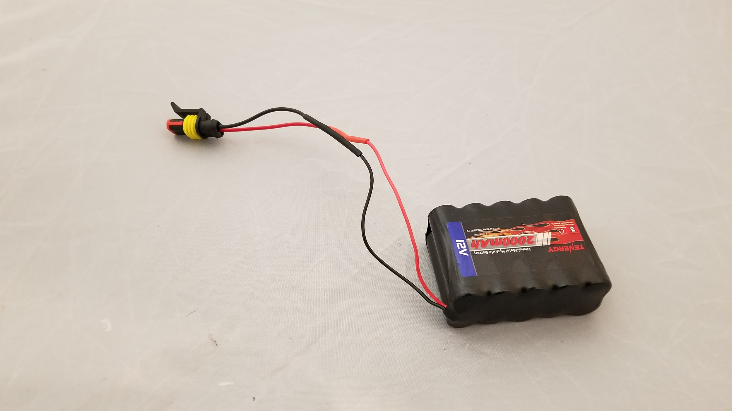

**Figure 10:** The female battery connector after being soldered to the battery.

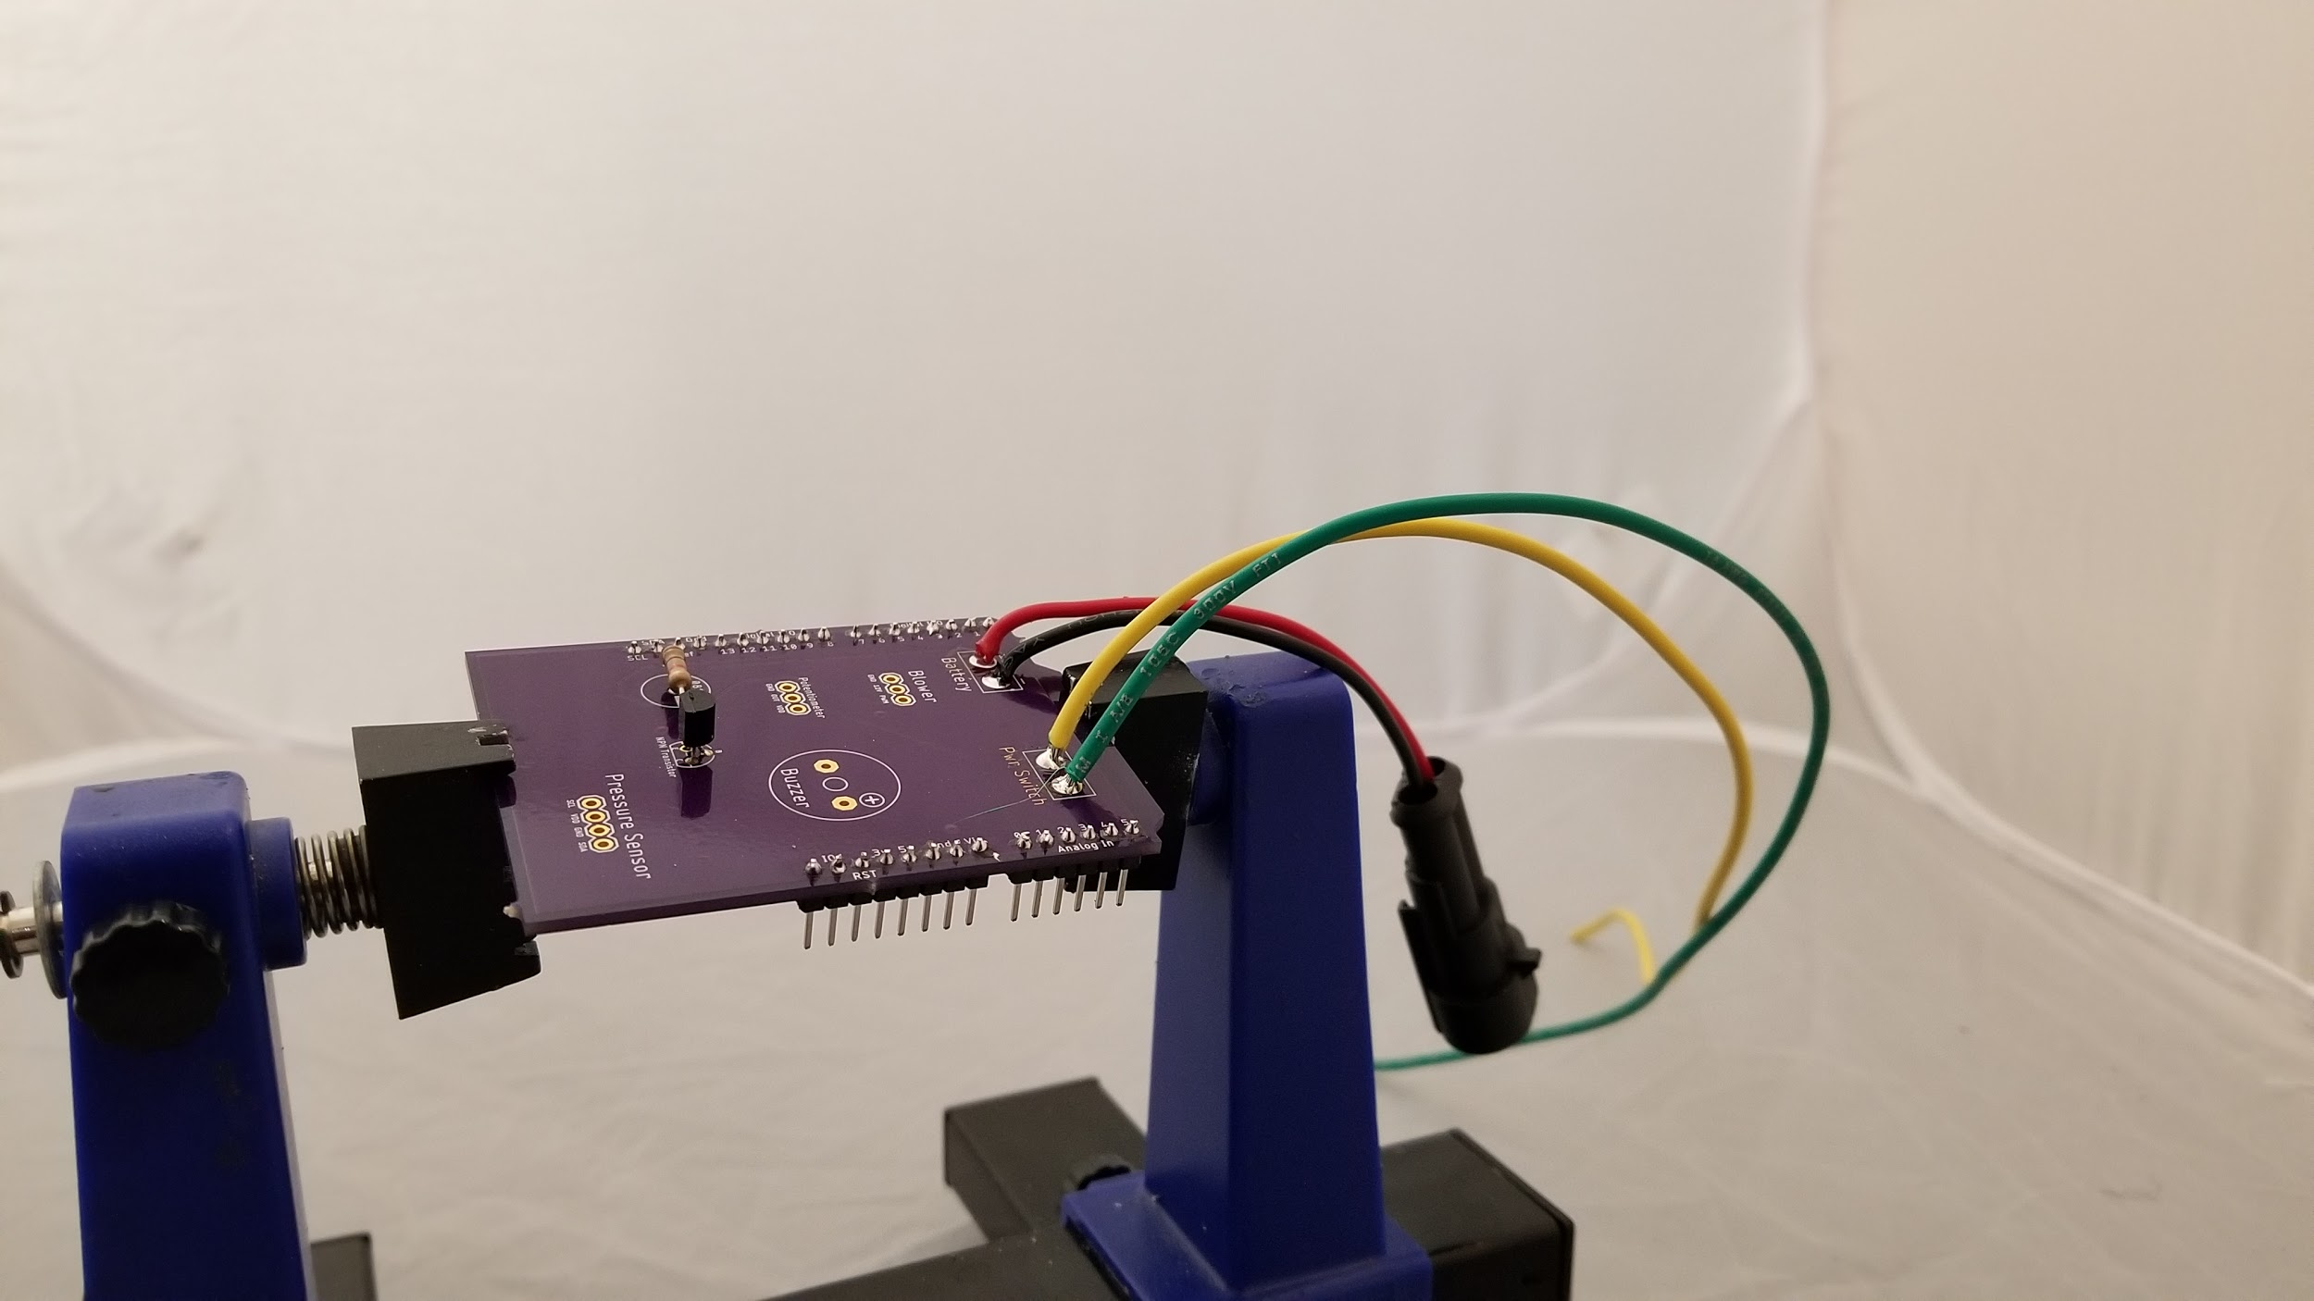 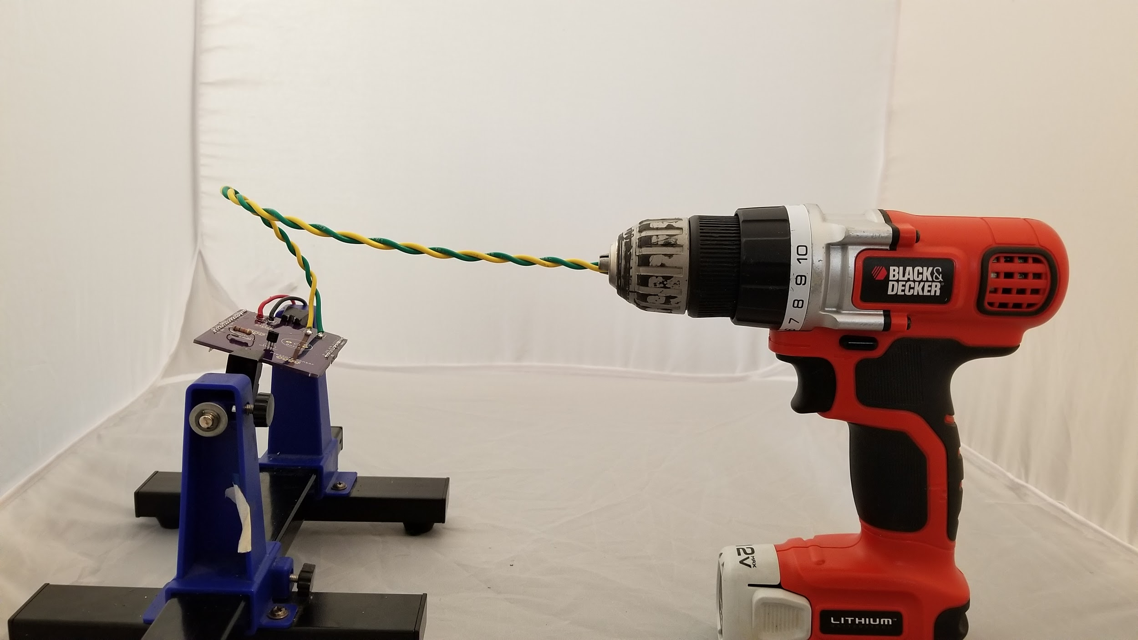

**Figure 11:** The power switch wires after being soldered to the PCB (left) and after being wound into a twisted pair by a power drill (right)

From here, the peripheral setup began. The blower motor wires were twisted in a power drill to simplify cable management. Three 12-inch 22-gauge wires were soldered to the rotary potentiometer **(Figure 12)**. From there, the wires from the blower were soldered to the board directly, with the black wire being in the *GND* position, the red wire being in the *12V* position, and the white wire being in the *PWM* position*.* The wires from the potentiometer are also soldered to the board, with the middle wire soldered to terminal labelled *Out* on the board. The other two wires can be soldered interchangeably. From there, the buzzer was then soldered directly to the board, with the positive terminal being soldered to the red wire, and the negative terminal soldered to the black wire. The final results thus far resembled **Figure 13**.

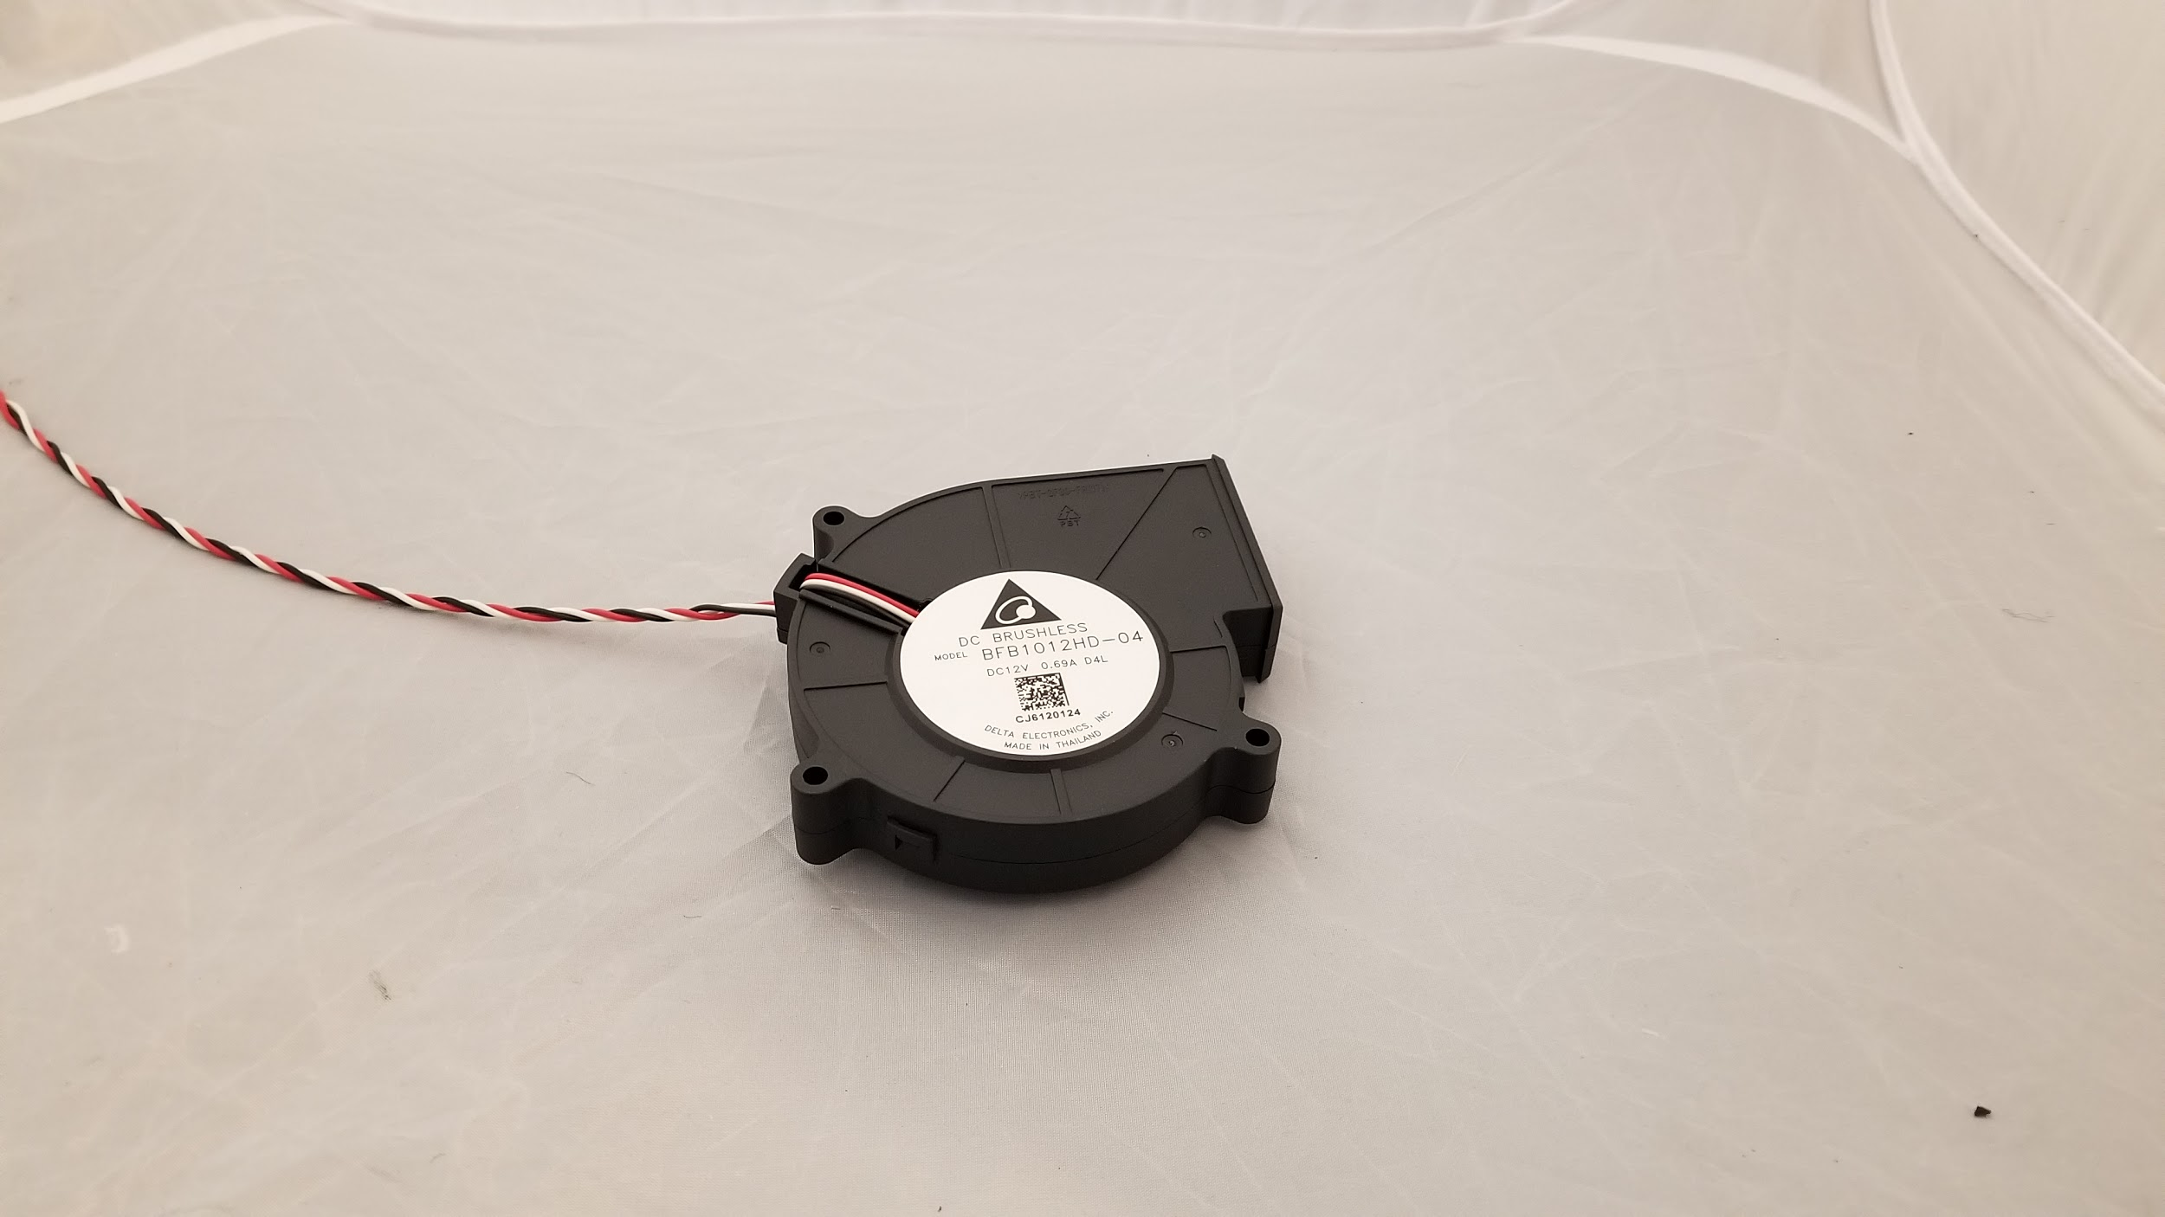 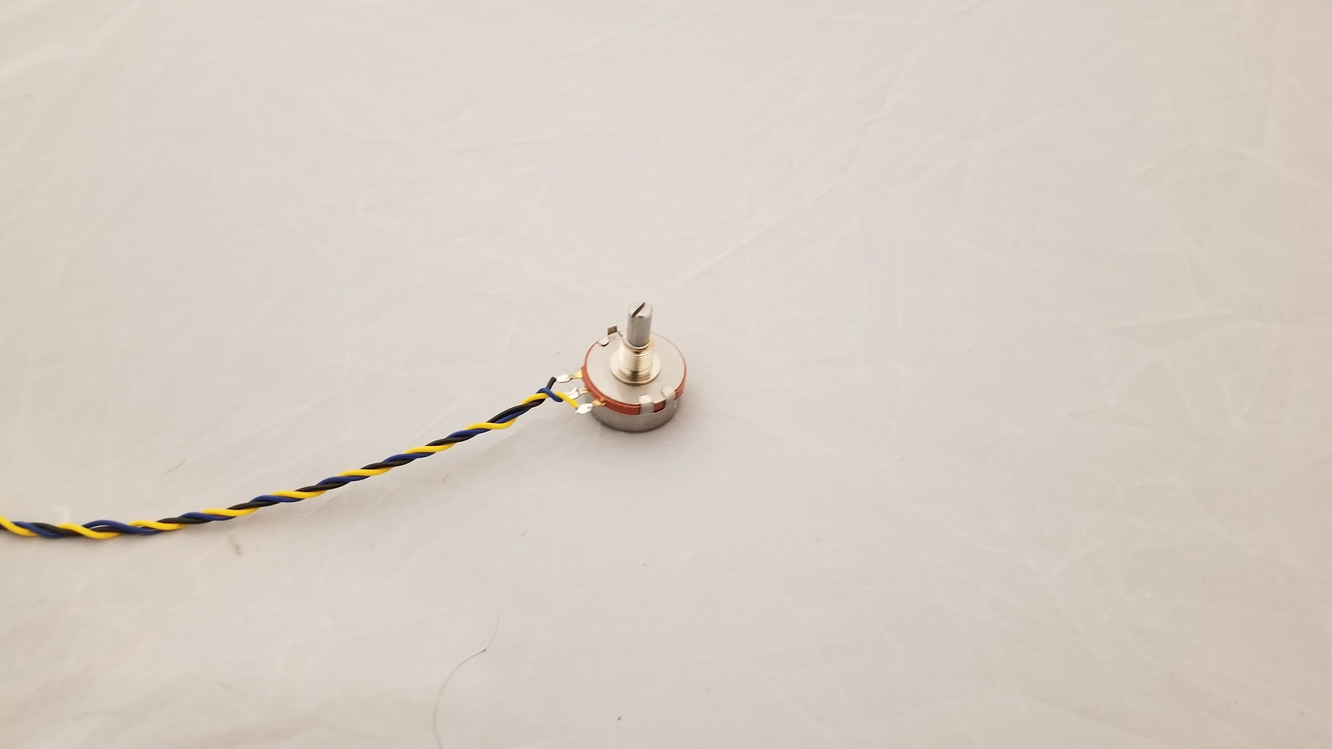

**Figure 12:** The blower motor after the wires were wound into a twisted pair for cable management purposes (left). The rotary potentiometer with wires soldered and twisted (right)

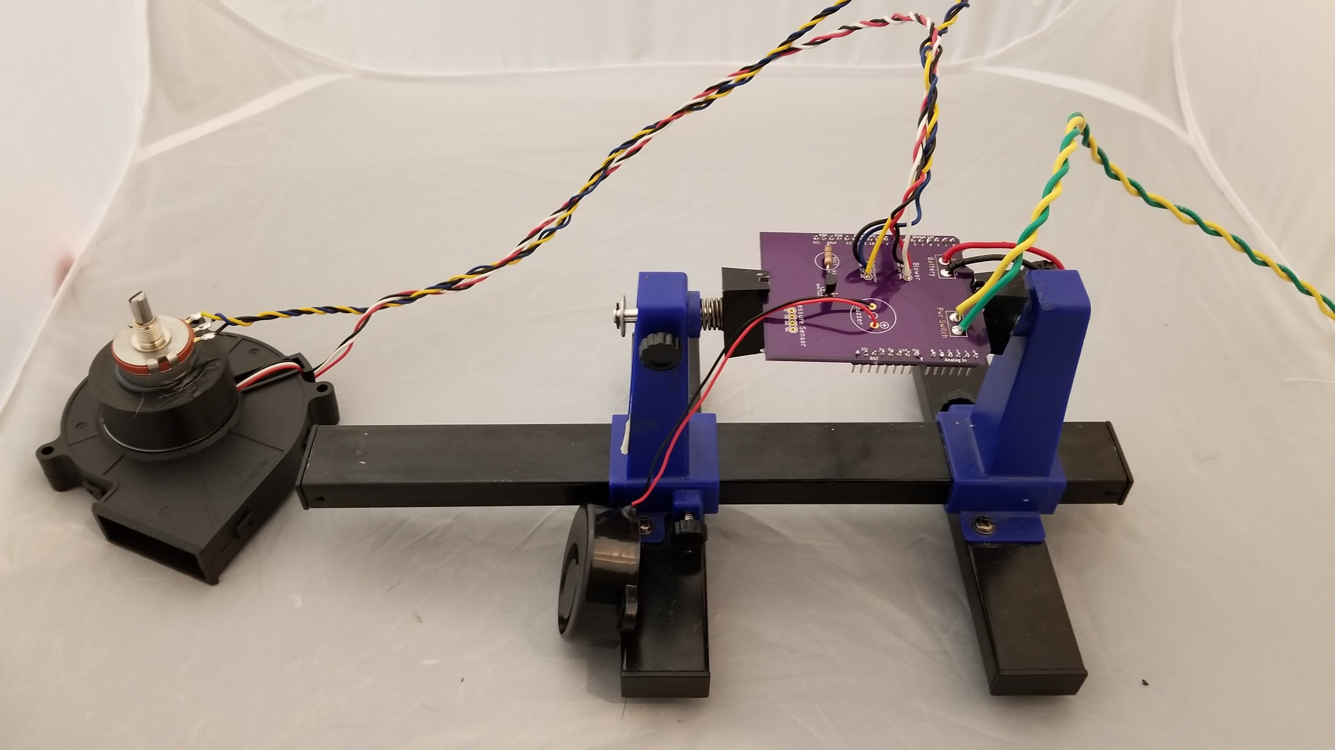

**Figure 13:** The PCB with various peripherals installed.

The bottom tabs are cut off from the pressure sensor, as shown in **Figure 14**. From there, the four leads are soldered to the board. The inlet and outlet ports should be facing the transistor previously soldered to the board, as shown in **Figure 15.** The PCB is then plugged directly into the Arduino Uno **(Figure 16)**. The two power switch wires are then screwed into the screw terminals on the power switch, as shown in **Figure 17.**

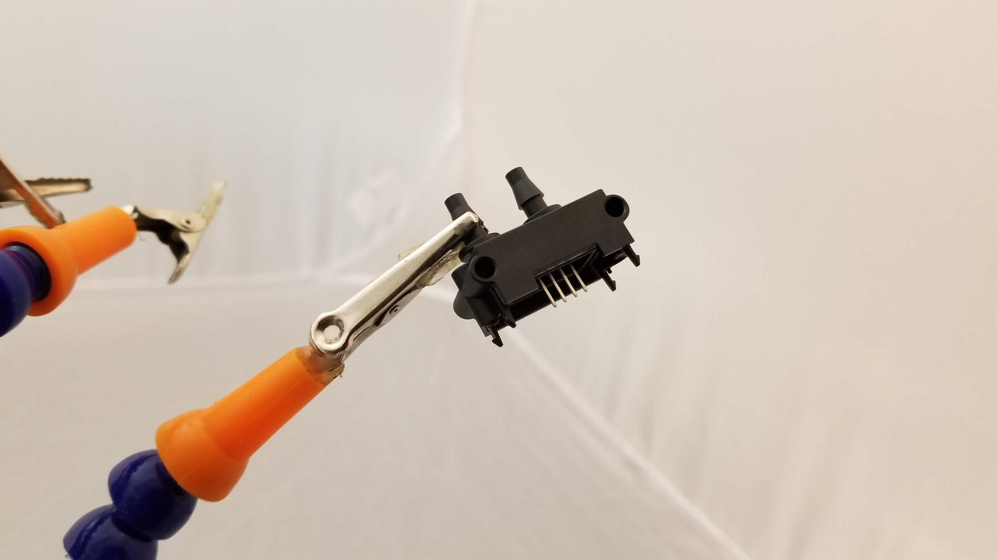 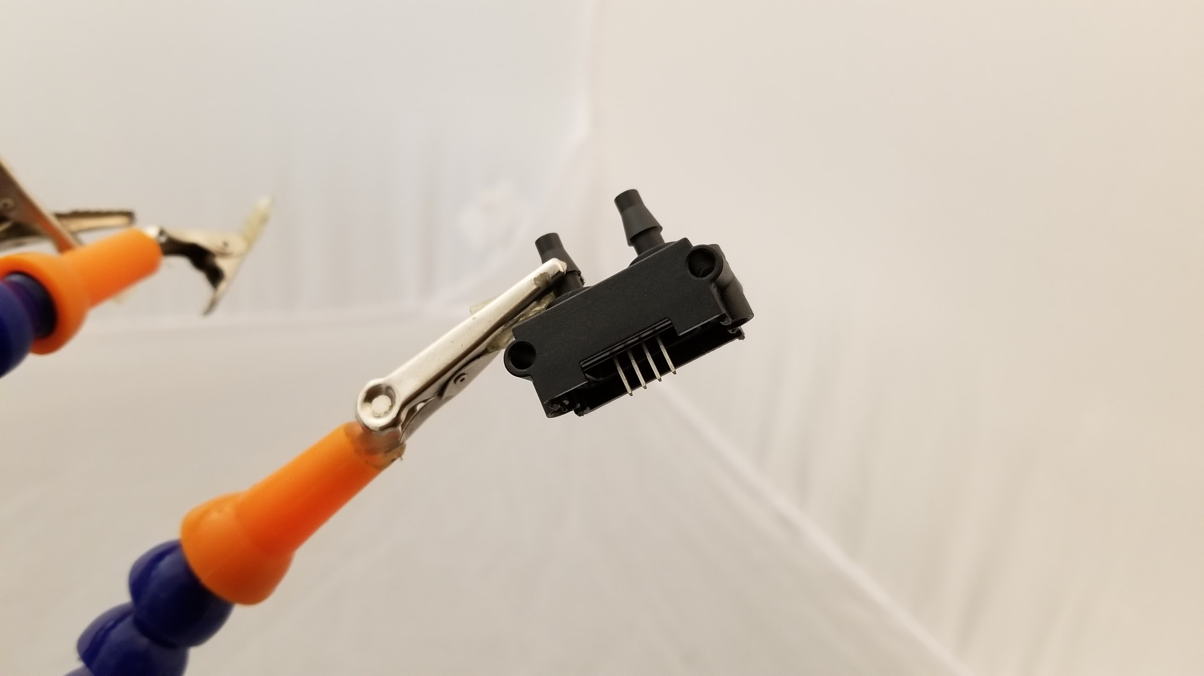

**Figure 14:** The differential pressure sensor before the tabs on the bottom are removed (left) and after (right).

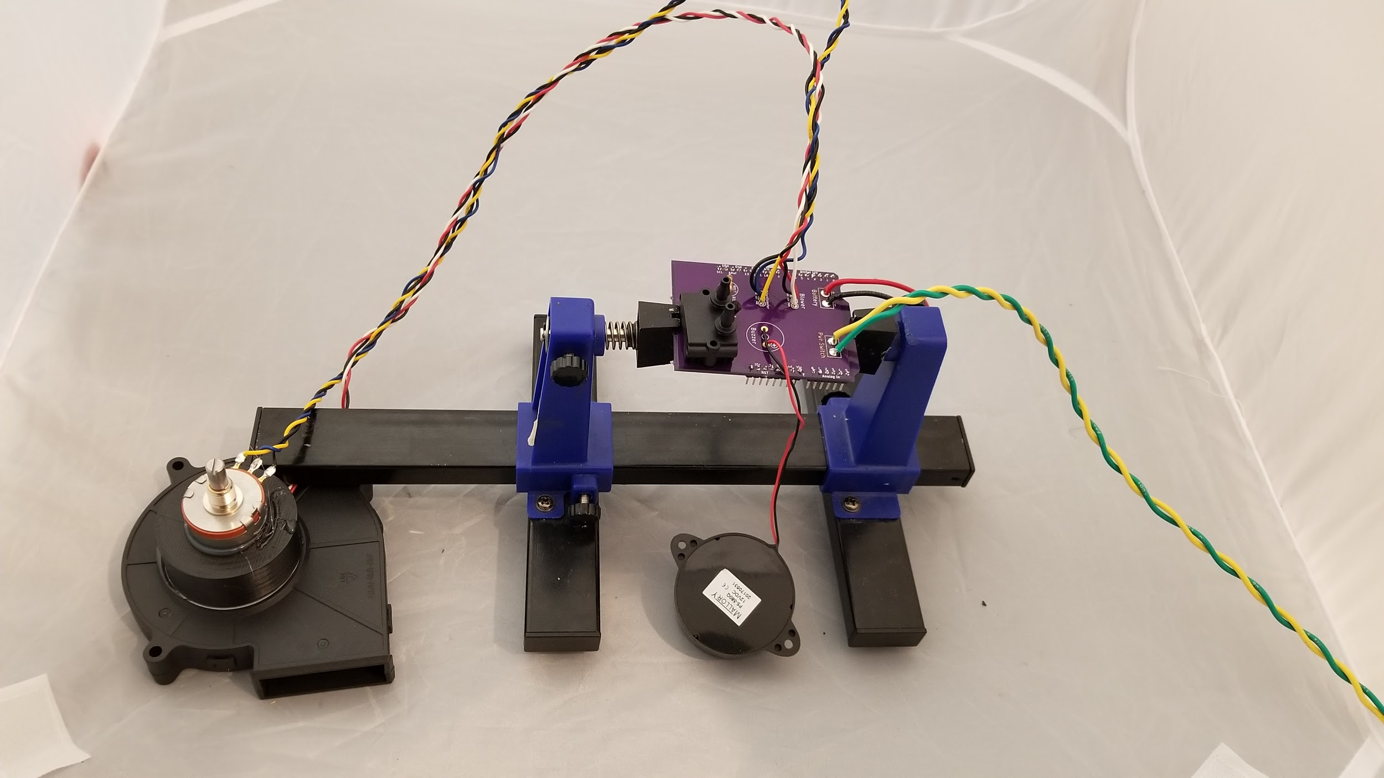

**Figure 15:** The PCB with the pressure sensor installed, before plugging into the Arduino Uno.

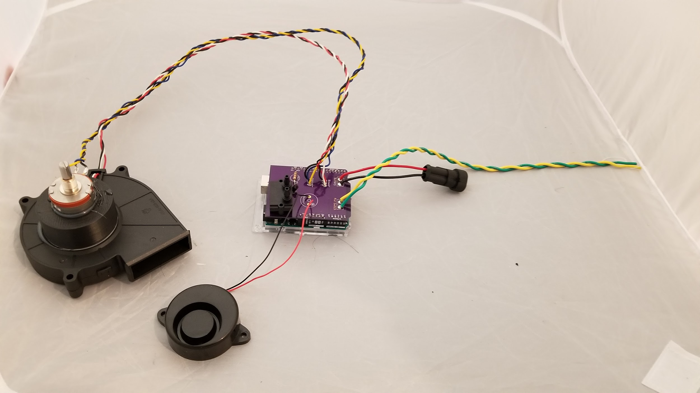

**Figure 16:** The PCB installed to the Arduino Uno. Connection to the battery and power switch not shown.

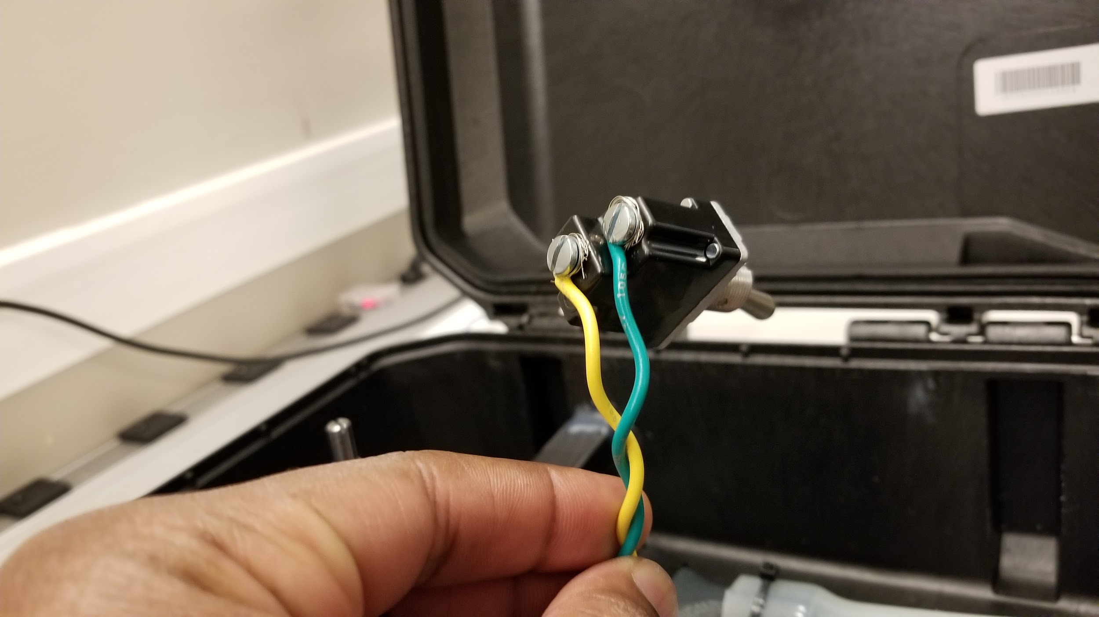

**Figure 17:** The two switch wires installed to the screw terminals.

Additionally, a custom mounting bracket was designed to keep the large blower in-line with the downstream path. The bracket was secured to the case and blower with hot-melt adhesive **Figure 18**. A 1-inch diameter piece of silicone tubing was used to connect the 3D-printed blower adapter, as shown in **Figure 19** in gray, to the black venturi used to measure outlet gas flow rate. Electrical tape was used to secure the 3D-printed blower adapter to the blower motor, and zip-ties to connect the silicone tubing to the blower adapter and venturi. The smaller diameter silicone tubing is connected from the black venturi ports to the differential pressure sensor ports- the pressure sensor port closest to the transistor on the PCB is connected to the port closest to the outlet on the venturi. The switch is placed through the smaller hole on the case, then a switch cover with sealing nut is screwed onto the body and further secured with Loctite Threadlocker Red 271 **(Figure 20)**. After the electrical connections were made, it was all mechanically fixed to the case with hot-melt glue, as ultimately shown in **Figure 21.**

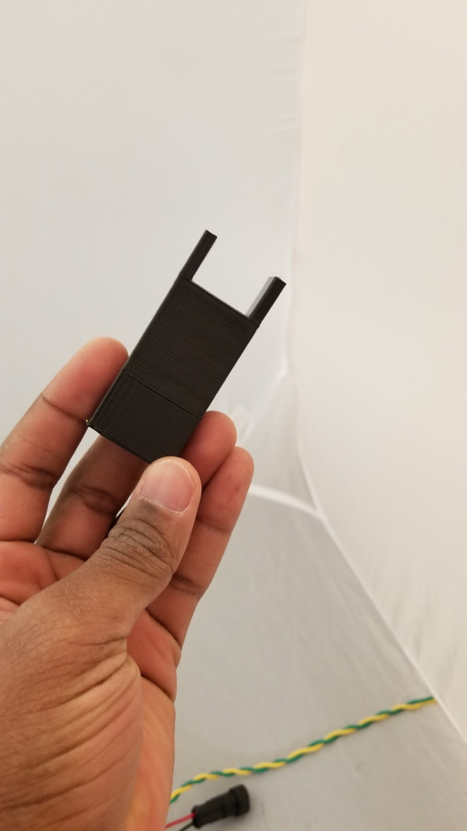 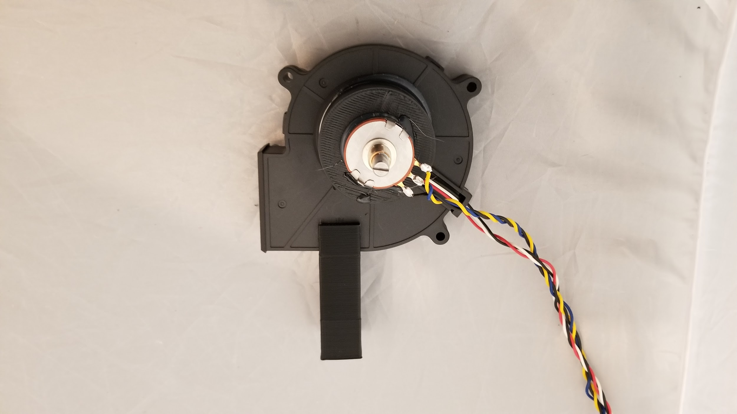

**Figure 18:** The custom blower mounting bracket piece as affixed to the blower motor.

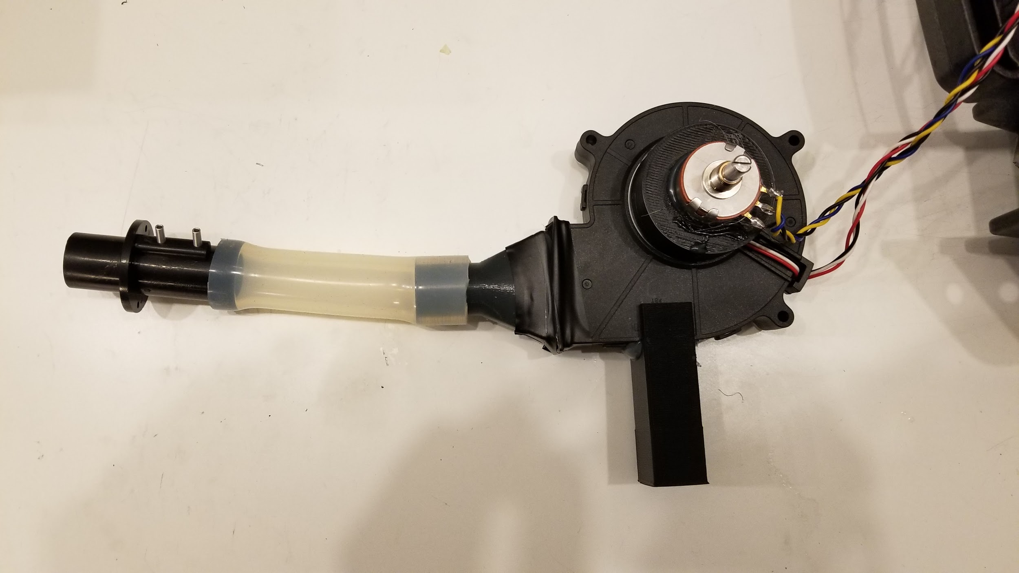

**Figure 19:** The attached silicone tubing with the venturi and 3D-printed blower adapter.

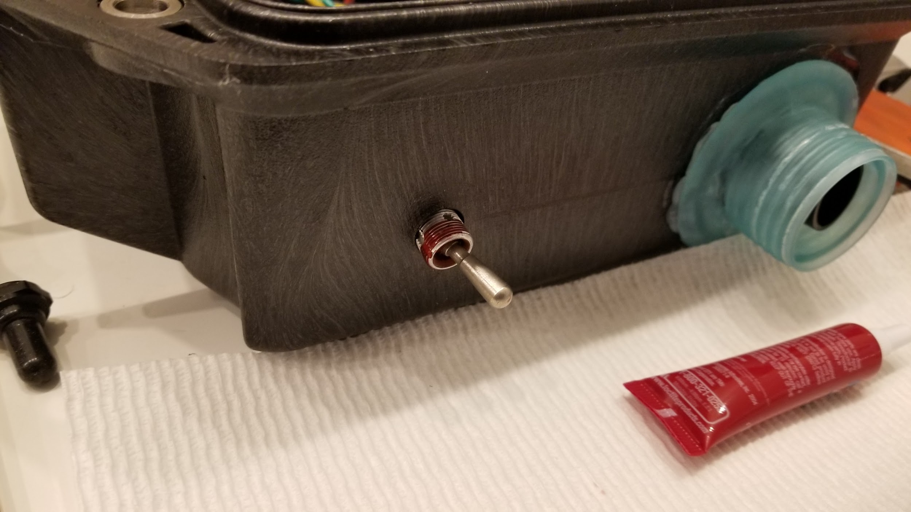

**Figure 20:** The switch with the Threadlocker applied, just before the switch cover with sealing nut is screwed on (shown on the left of the picture).

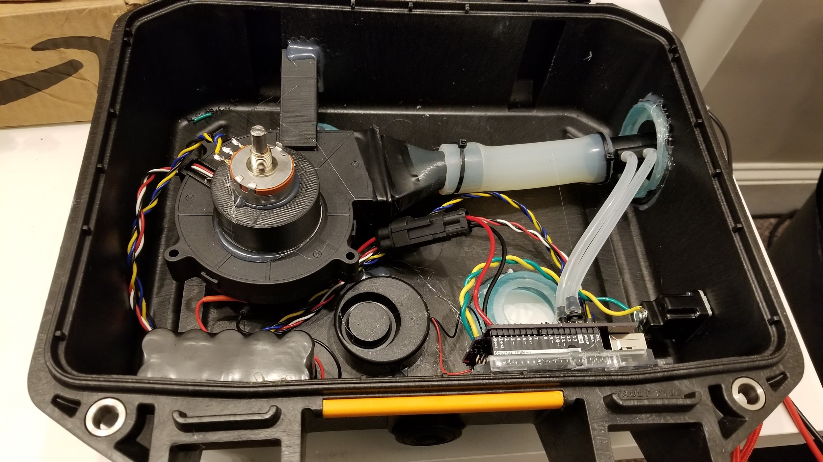

**Figure 21:** A photo of the finished connections of the prototype.

Programming

To complete the setup, the Arduino Uno controlling the electronics for the prototype had to be programmed with proper firmware. A standard USB cable was connected to the prototype and a computer running current Arduino software. The prototype board was enumerated as a serial port on the computer. From there, the relevant firmware, located on a shared Git-style repository, and on **Supplementary Material 4** was used.

**OPTIONAL DESIGN- ARDUINO PROTOSHIELD**

Earlier versions of this design used an Arduino Protoshield **(Figure 22)** to connect the components instead of a custom PCB. The electrical configuration of said components, however, was identical**.** Using general-purpose 22-gauge wire for the signal connections and 18-gauge wire for the NiMH battery connections and switch, the schematic described in **Figure 3** was usedto electrically connect the prototype together. This Protoshield electrically connected to the Arduino Uno to provide functionality.

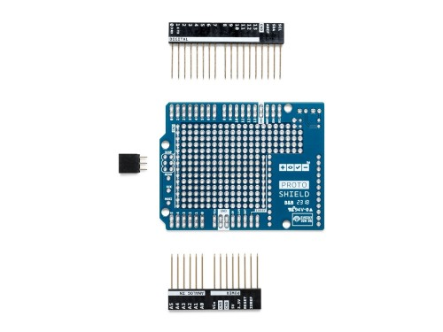

**Figure 22:** The original Arduino Protoshield used in earlier versions of the prototype.